IMPORTANT FIRST : IF YOU GET AN ERROR LOOK LIKE THIS IN EXTRACT PROCESS :

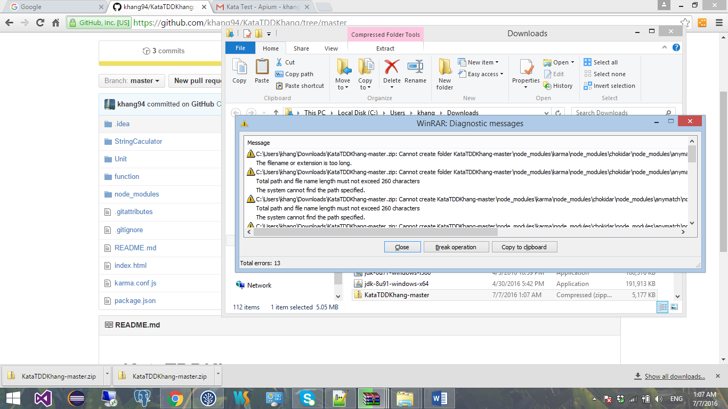

Do not use this extract file because there are some js.file cannot be extract so it would get an error when you are debugging .

You should move this zip file directly the other DISK : Ex F:\KataTDDKhang-master (just ensure the path is not too long).

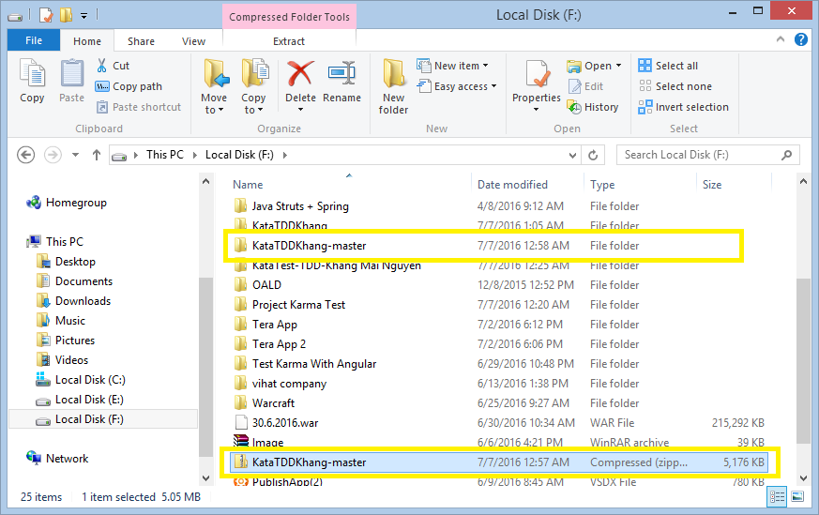

1. Extract normally (without error) you will got a folder look like :

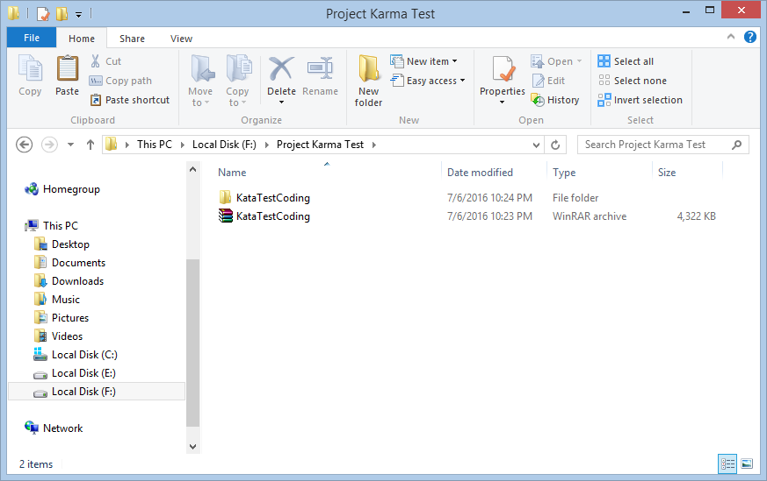

1. Then open this project by the webstorm (The tool that I used is Webstorm 11.)

You must open the folder which contains directly the source code to get debug success (not the parent folder).

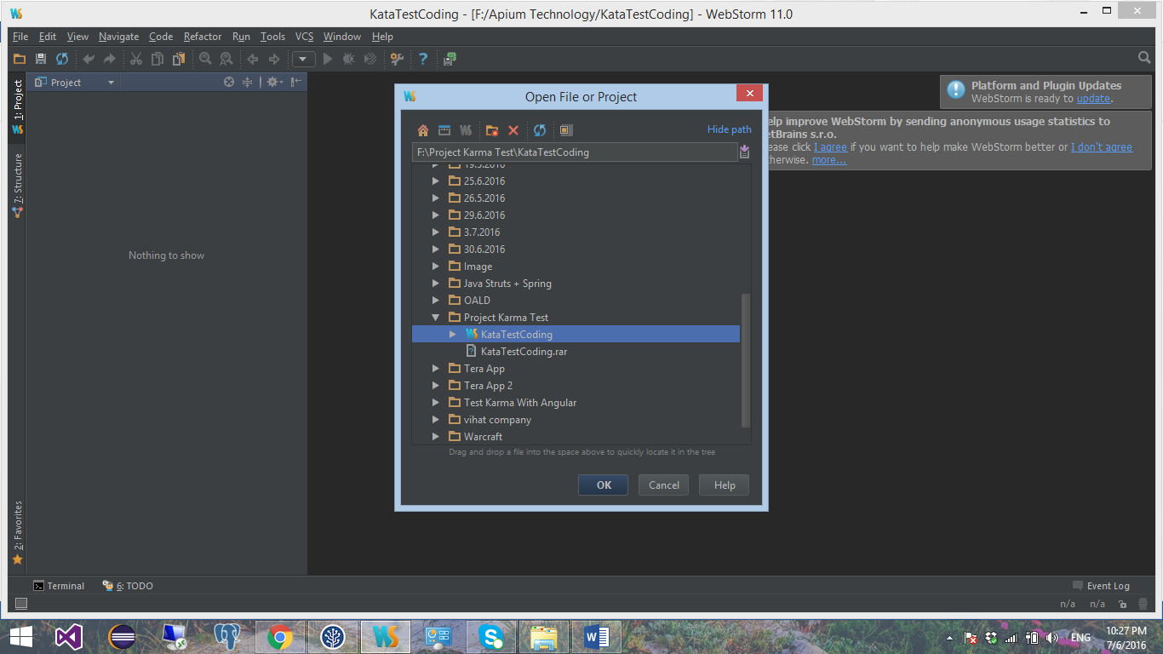

And it look like this . You should check the karma.conf.js file which I included that must have the folder of running file : files:[‘StringCaculator/\*.js’] as below capture .

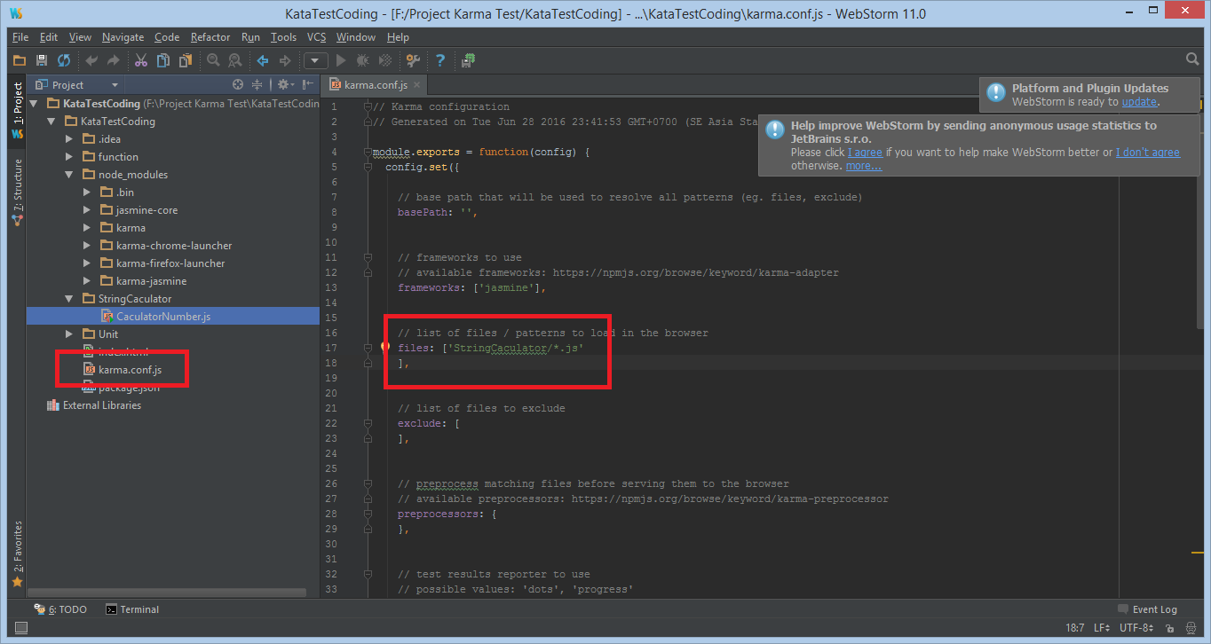

3.1 Then run debug , it will show the brower with url : 9876 and wating second to get a result .

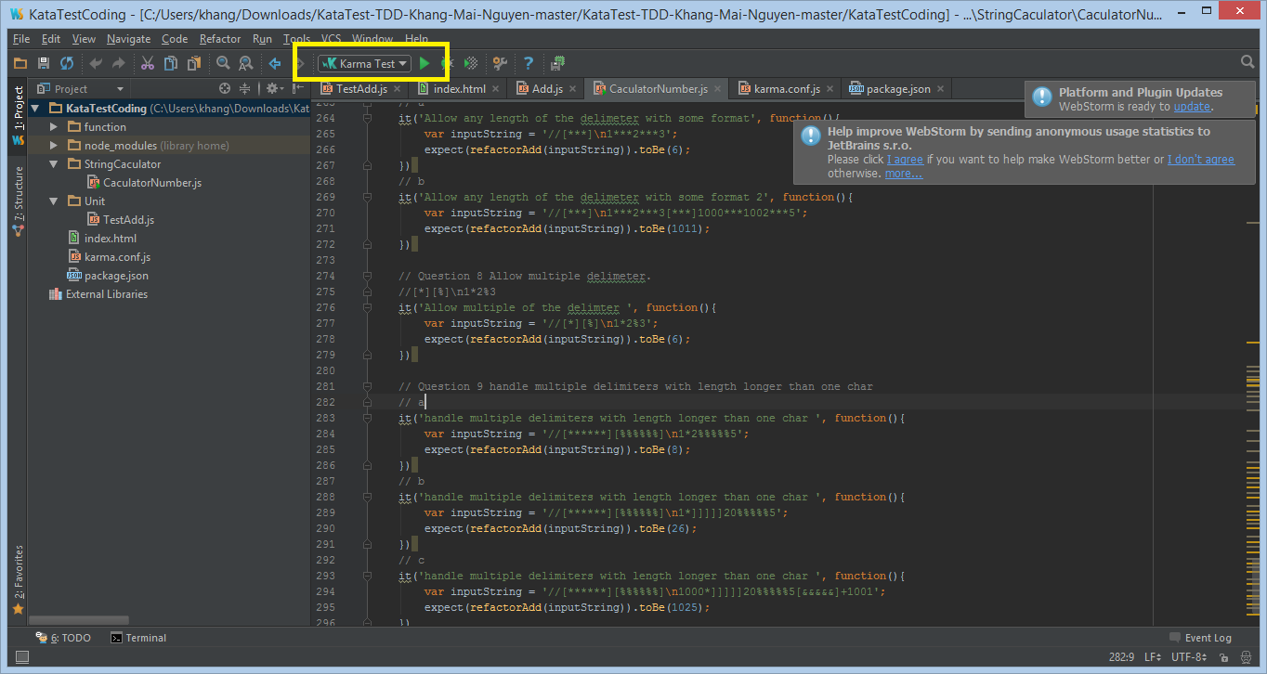

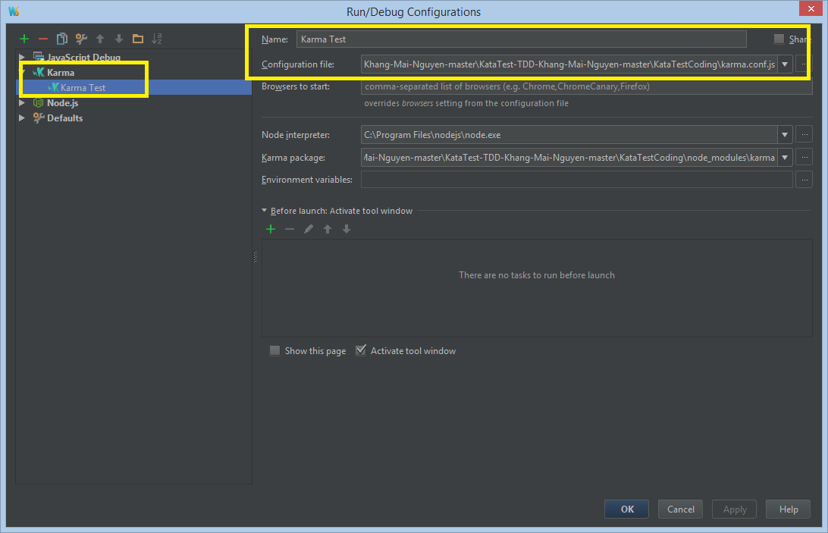

Run the test and get the result .

It will show the browser with url : <http://localhost:9876/?id=17963167>

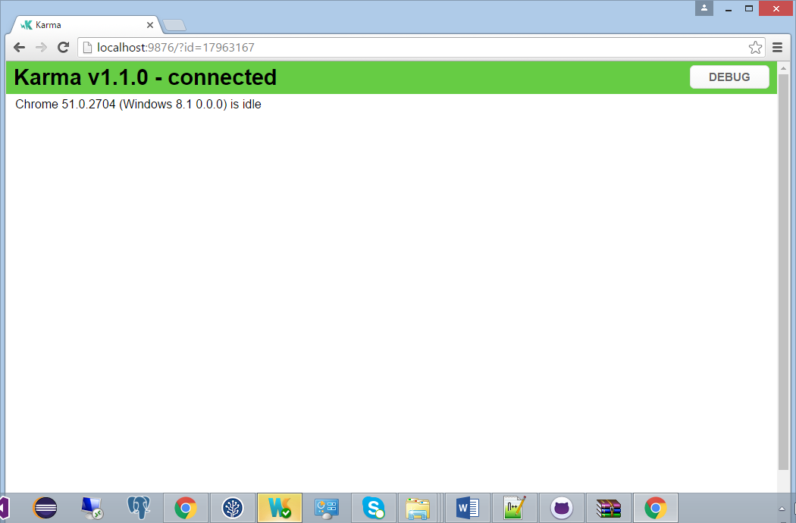

And you will get the final result .

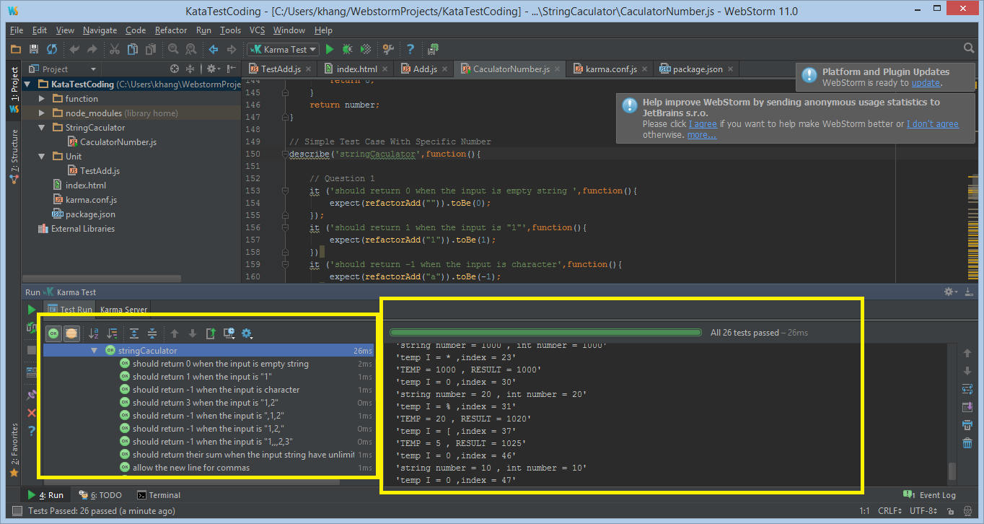

3.2 If it is not automatically add the karma test that I’ve configured you should click Edit Configuration then to create new karma test which reference this karma.conf.js file.

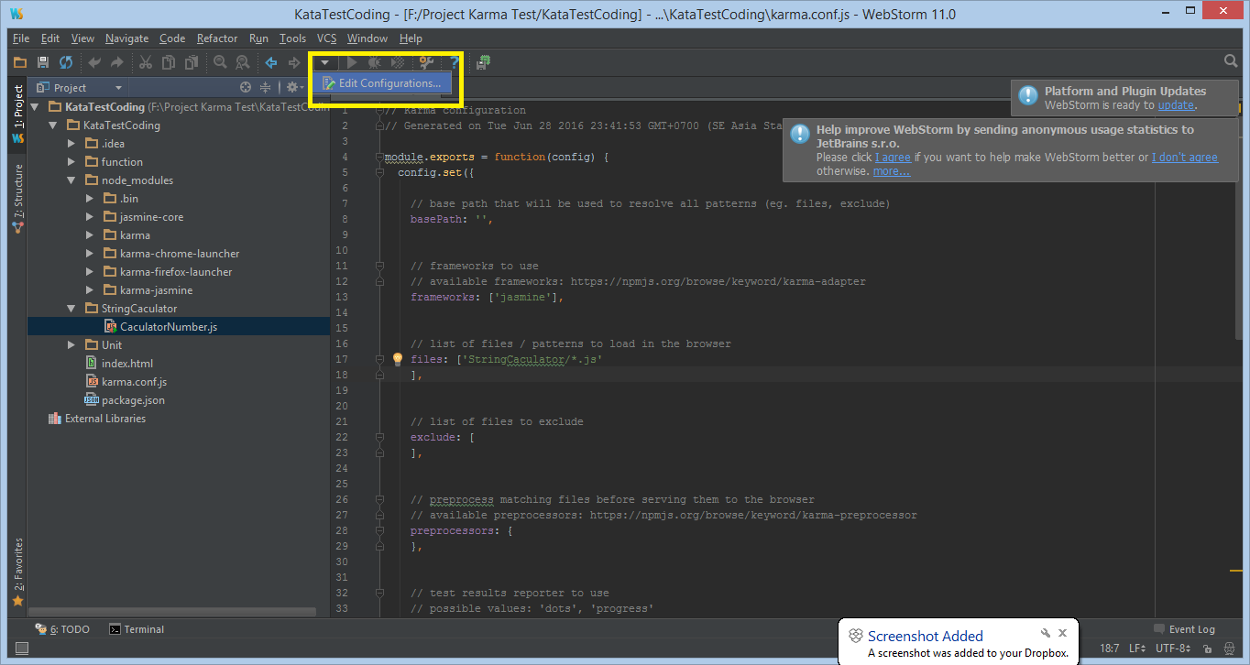

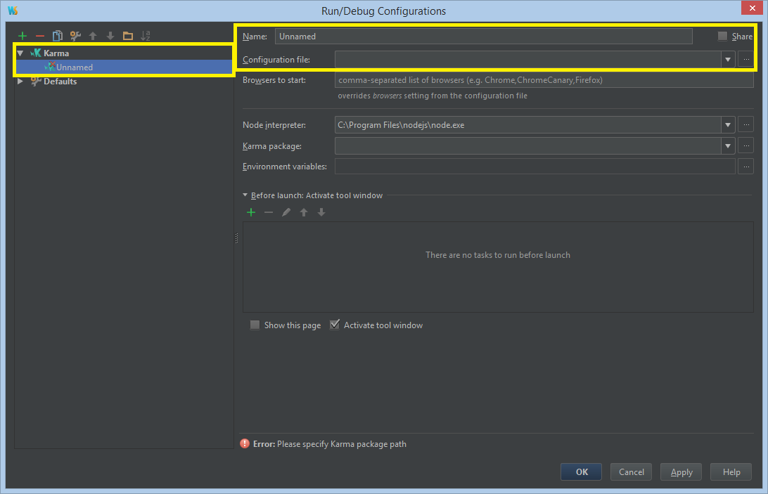

Then choose the file Karma.conf.js to this path.

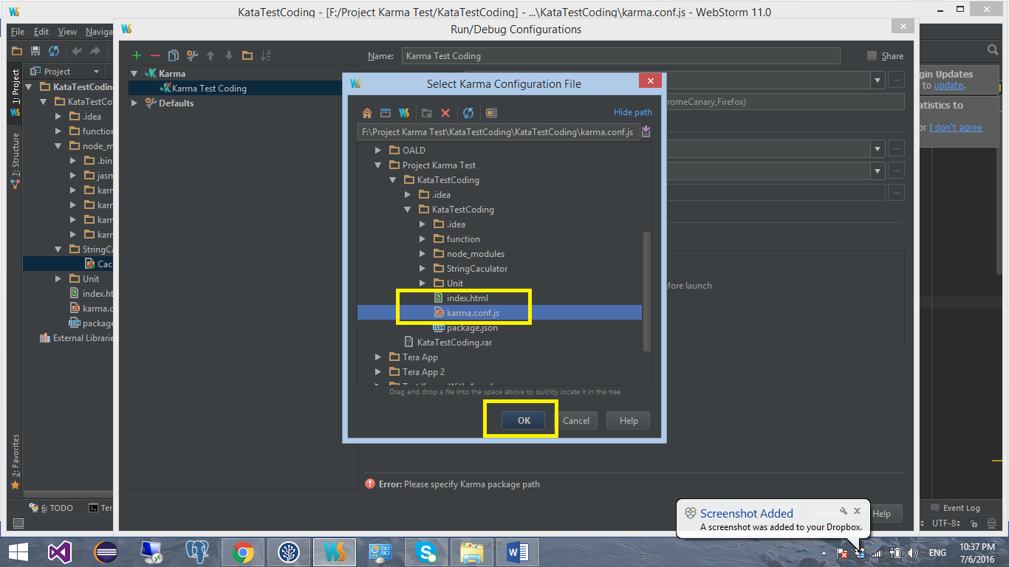

And it will look like this , then click apply and ok to prepare for running the test .

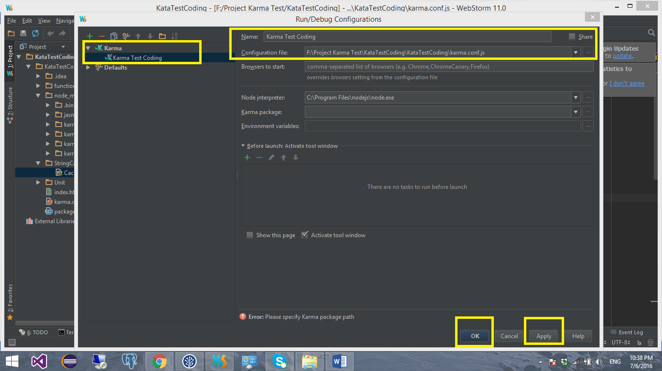

1. After the , the screen look like this :

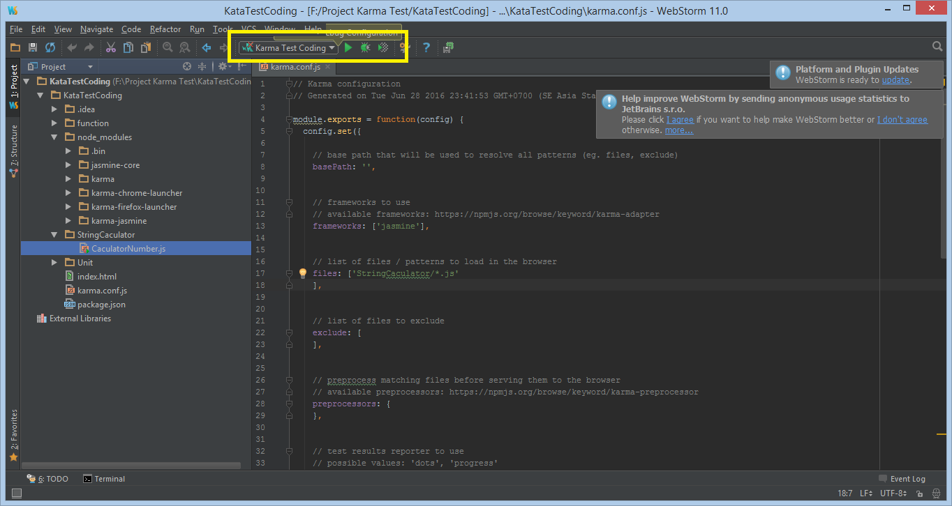

1. Excute the code and get the result .

